**DSA ASSIGNMENT-7**

**TANISHA KARMAKAR**

**21051950**

**CSE 37**

**Q1. WAP to create a Binary tree and perform the In-order traversal (non-recursive).**

#include<stdio.h>

struct node

{

    int data;

    struct node *lc, *rc;

};

void create(struct node *ptr)

{

    int choice;

    printf("Enter data : ");

    scanf("%d",&ptr->data);

    ptr->lc = NULL;

    ptr->rc = NULL;

    printf("left child of %d?(0/1) : ",ptr->data);

    scanf("%d",&choice);

    if(choice == 1)

    {

        struct node *new = (struct node*)malloc(sizeof(struct node));

        ptr->lc = new;

        create(new);

    }

    printf("right child of %d?(0/1) : ",ptr->data);

    scanf("%d",&choice);

    if(choice == 1)

    {

        struct node *new = (struct node*)malloc(sizeof(struct node));

        ptr->rc = new;

        create(new);

    }

}

struct node *stack[100];

int top = -1;

void push(struct node *data)

{

    top++;

    stack[top] = data;

}

void pop()

{

    if(top == -1)

        printf("\nstack underflow!");

    else

    {

        printf("%d ",stack[top]->data);

        top--;

    }

}

void inorder(struct node *root)

{

    struct node *ptr;

    ptr = root;

    while(ptr != NULL || top != -1)

    {

        while(ptr != NULL)

        {

            push(ptr);

            ptr = ptr->lc;

        }

        ptr = stack[top];

        pop();

        ptr = ptr->rc;

    }

}

int main()

{

    struct node *root = (struct node *)malloc(sizeof(struct node));

    create(root);

    printf("non recursive inorder traversal : ");

    inorder(root);

}

**OUTPUT:**

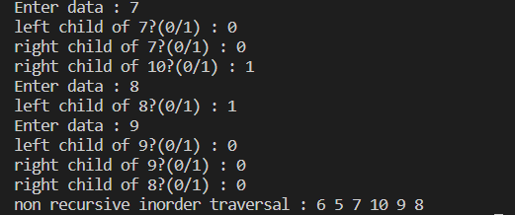

**Q.2 WAP to create a Binary tree and perform the Pre-order traversal (non-recursive).**

#include<stdlib.h>

#include<stdio.h>

struct node

{

    int data;

    struct node *lc, *rc;

};

void create(struct node *ptr)

{

    int choice;

    printf("Enter data : ");

    scanf("%d",&ptr->data);

    ptr->lc = NULL;

    ptr->rc = NULL;

    printf("left child of %d?(0/1) : ",ptr->data);

    scanf("%d",&choice);

    if(choice == 1)

    {

        struct node *new = (struct node*)malloc(sizeof(struct node));

        ptr->lc = new;

        create(new);

    }

    printf("right child of %d?(0/1) : ",ptr->data);

    scanf("%d",&choice);

    if(choice == 1)

    {

        struct node *new = (struct node*)malloc(sizeof(struct node));

        ptr->rc = new;

        create(new);

    }

}

struct node *stack[100];

int top = -1;

void push(struct node *data)

{

    top++;

    stack[top] = data;

}

void pop()

{

    if(top == -1)

        printf("\nstack underflow!");

    else

    {

        printf("%d ",stack[top]->data);

        top--;

    }

}

void preorder(struct node *root)

{

    struct node *ptr;

    ptr = root;

    push(root);

    while(ptr != NULL || top != -1)

    {

        ptr = stack[top];

        pop();

        if(ptr->rc!=NULL)

        {

        push(ptr->rc);

        }

        if(ptr->lc!=NULL)

        {

        push(ptr->lc);

        }

    }

}

int main()

{

    struct node *root = (struct node *)malloc(sizeof(struct node));

    create(root);

    printf("non recursive preorder traversal : ");

    preorder(root);

}

**OUTPUT:**

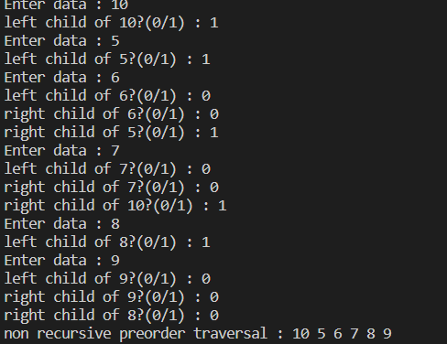

**Q.3 WAP to create a Binary tree and perform the Post-order traversal (non-recursive).**

/*wap to create a binary tree and perform the post-order traversal(non recursive)*/

#include<stdio.h>

#include<stdlib.h>

struct node

{

    int data;

    struct node *lc, *rc;

};

void create(struct node *ptr)

{

    int choice;

    printf("data : ");

    scanf("%d",&ptr->data);

    ptr->lc = NULL;

    ptr->rc = NULL;

    printf("left child of %d? : ",ptr->data);

    scanf("%d",&choice);

    if(choice == 1)

    {

        struct node *new = (struct node*)malloc(sizeof(struct node));

        ptr->lc = new;

        create(new);

    }

    printf("right child of %d? : ",ptr->data);

    scanf("%d",&choice);

    if(choice == 1)

    {

        struct node *new = (struct node*)malloc(sizeof(struct node));

        ptr->rc = new;

        create(new);

    }

}

struct node *stack[100];

int top = -1;

void push(struct node *data)

{

    top++;

    stack[top] = data;

}

void pop()

{

    if(top == -1)

        printf("\nstack underflow!");

    else

    {

        top--;

    }

}

void postorder(struct node *root)

{

    struct node *ptr = root;

    while(ptr != NULL)

    {

        push(ptr);

        if(ptr->rc != NULL)

            push(ptr->rc);

        ptr = ptr->lc;

    }

    ptr = stack[top];

    printf("%d ",stack[top]->data);

    pop();

    if(ptr->rc != NULL && ptr->rc == stack[top])

    {

        pop();

        push(ptr);

        ptr = ptr->rc;

    }

    else

        ptr = NULL;

    while(top != -1)

    {

        while(ptr != NULL)

        {

            push(ptr);

            if(ptr->rc != NULL)

                push(ptr->rc);

            ptr = ptr->lc;

        }

        ptr = stack[top];

        printf("%d ",stack[top]->data);

        pop();

        if(ptr->rc != NULL && ptr->rc == stack[top])

        {

            pop();

            push(ptr);

            ptr = ptr->rc;

        }

        else

            ptr = NULL;

    }

}

int main()

{

    struct node *root = (struct node*)malloc(sizeof(struct node));

    create(root);

    printf("non recursive\n");

    postorder(root);

}

**OUTPUT:**

